HW#3 MIPS ALU Simulation Report

I.D. 201322708 Tal Kain

I.D. 300267390 Idan Ben-Zvi

I.D. 204200026 Michal Momika

Screen Capture

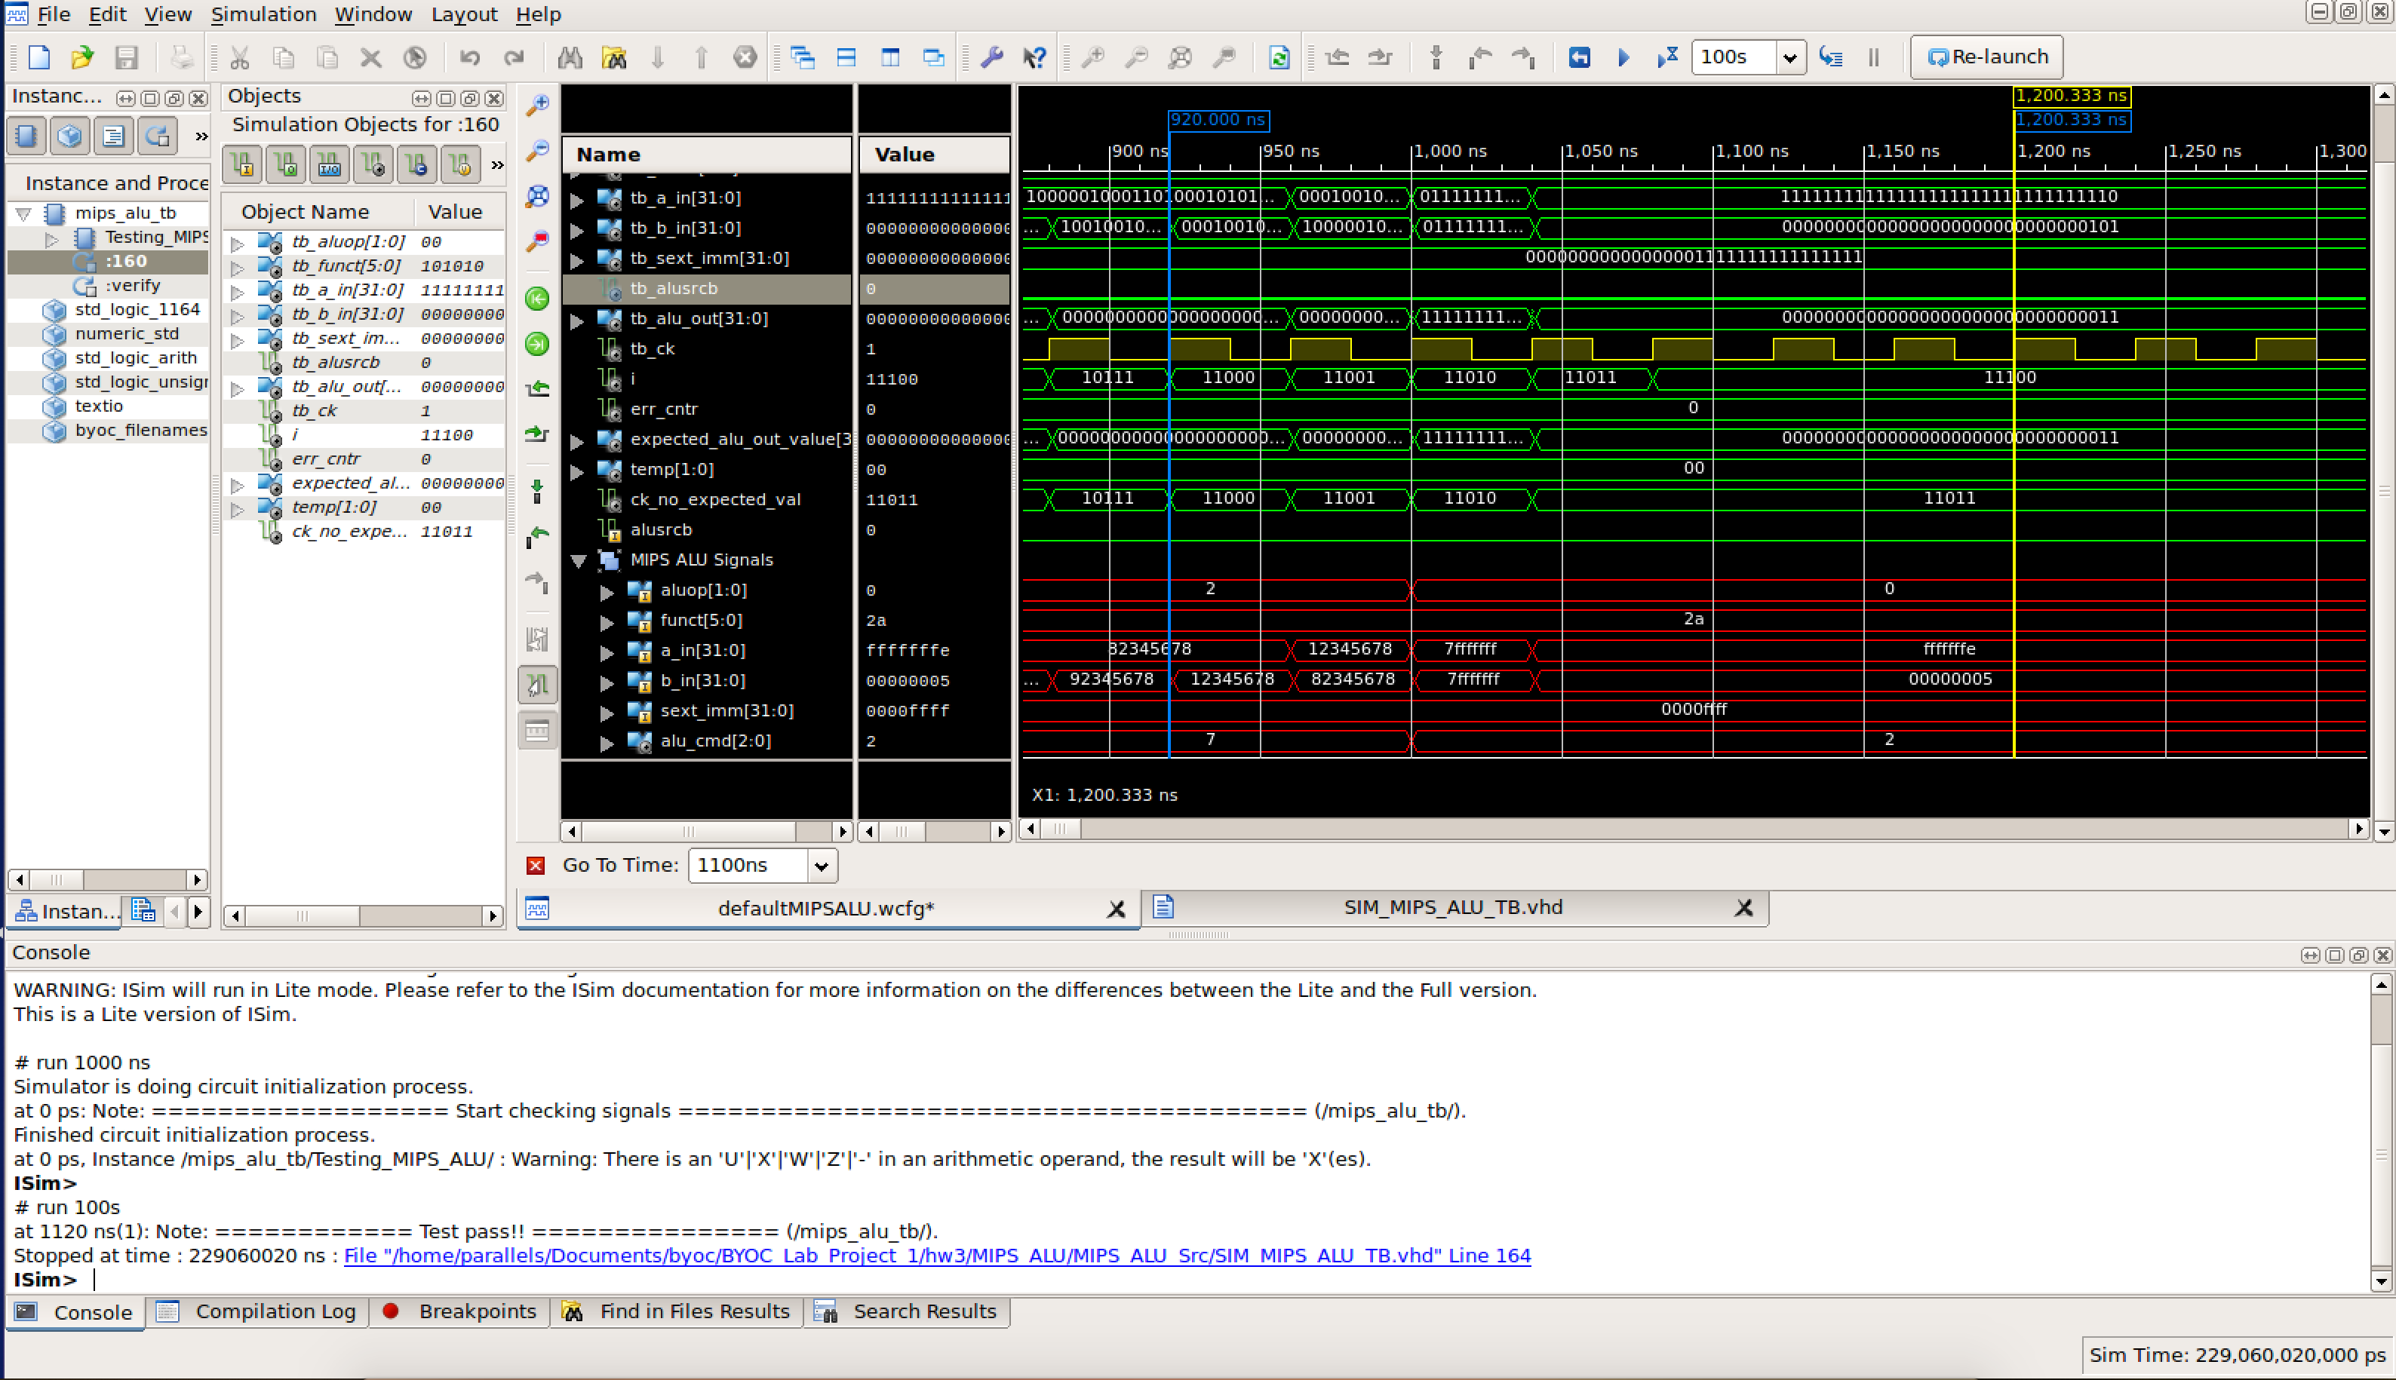

Disassembly Explanation